Stovall Middle School
Aldine Independent School District

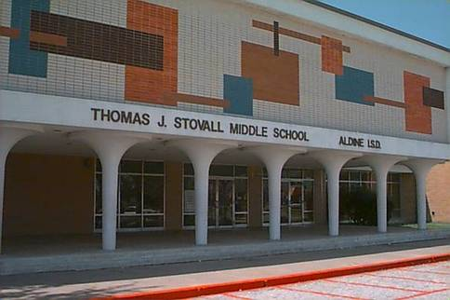
Educating the Community for 50 Years!

11201 Airline Drive
Houston, TX 77037

Elsa Wright, Principal
Deborah Willis, Assistant Principal
Maria Castillo, Assistant Principal
Robin Willis, Assistant Principal
Eric Themas, Assistant Principal

Motto
Gearing Up For the Win!

Mission

Stovall Middle School will present educational programs to assist each student to achieve academically, socially, and physically according to his ability, thereby enabling the student to achieve a positive self-image, realize the benefits of higher learning, and recognize education as a lifetime goal.

www.stovallms.aldineisd.org





Faculty

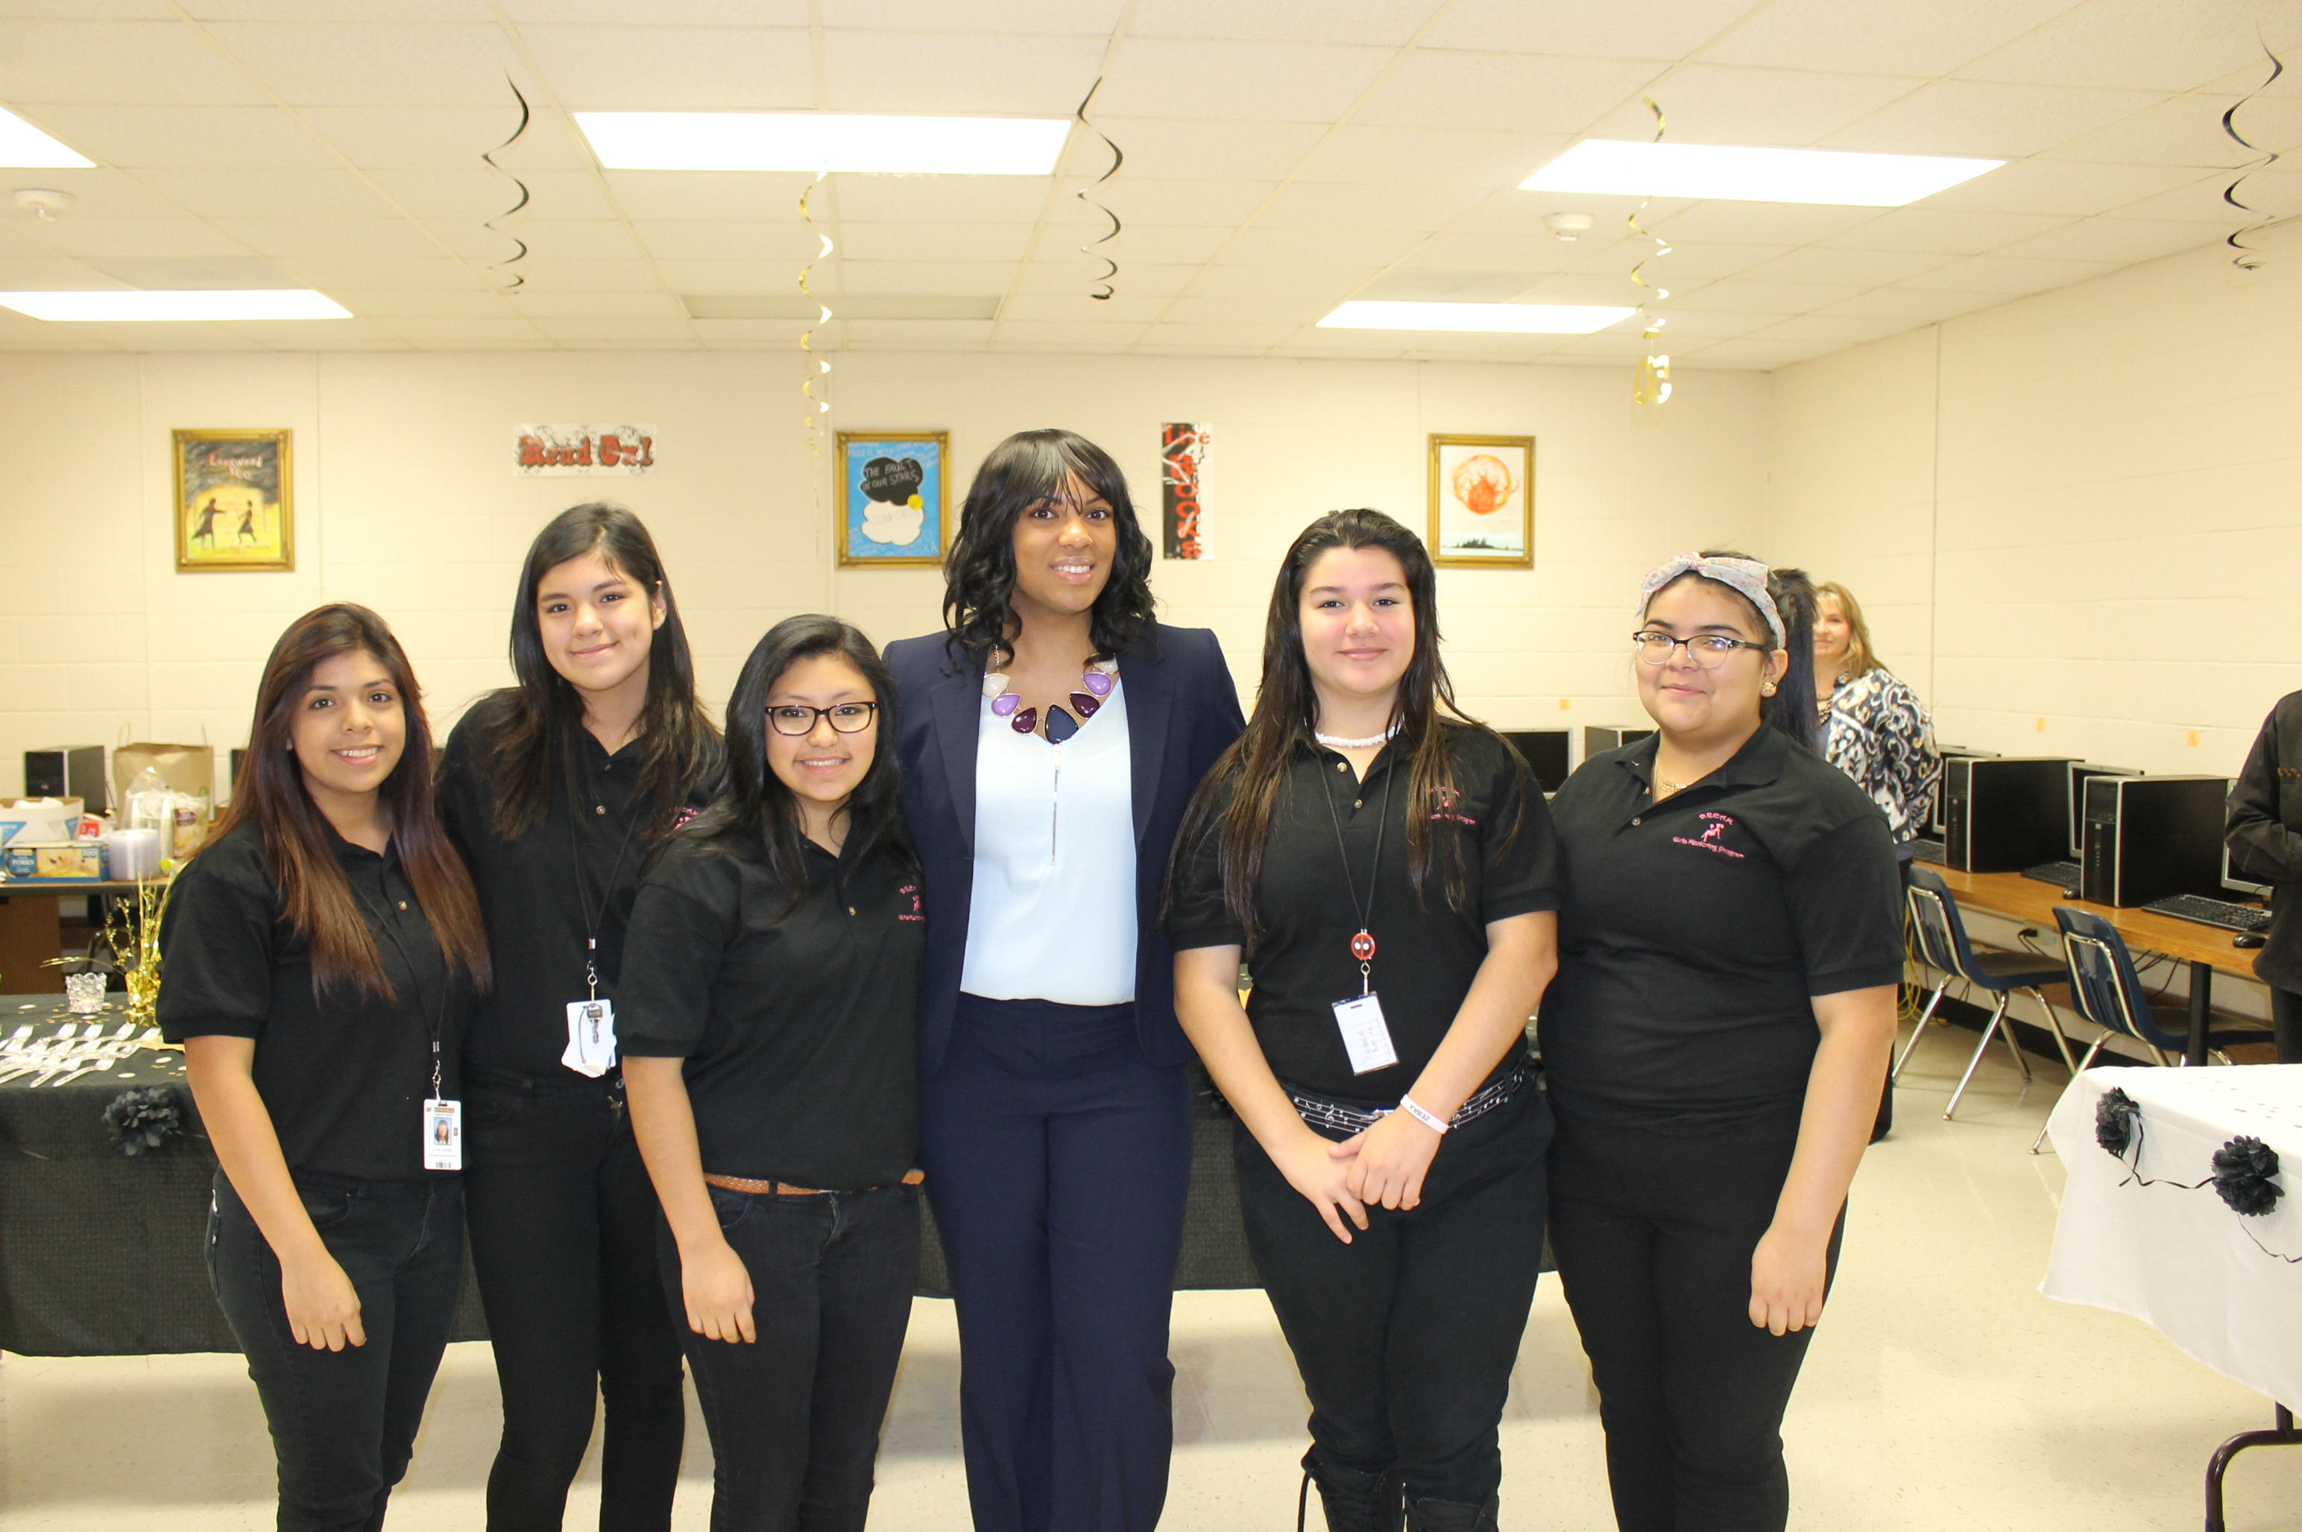

Total Staff: 84
Teachers: 63
Professional Support: 10
Administrators: 4
Educational Aides: 7

Teacher Ethnicity Count:
African American: 24
Hispanic: 7
White: 28
American Indian: 1
Asian: 2
Two or more races: 1

Teacher Experience:

Years of Experience | # of Teachers
0 (New Teacher) | 4
1-5 | 18
6-10 | 10
11-20 | 20
21 or more | 11



Vision and History

Aldine's Vision:
Produce the Nation’s Best

Aldine’s Mission:
We exist to prepare each student academically and socially to be a:

- Critical thinker
- Problem solver; and
- Responsible and productive citizen.
History:
When the school was built in 1964, it was named after Thomas J. Stovall. Stovall was a county and regional judge for 38 years before retiring in 1996. Stovall not only proved an outstanding judge in many celebrated cases, he also helped to bring about the county's one-day, one-trial jury service, a practice copied around the nation. He also worked to simplify instructions to jurors and improve the county's judicial record-keeping.

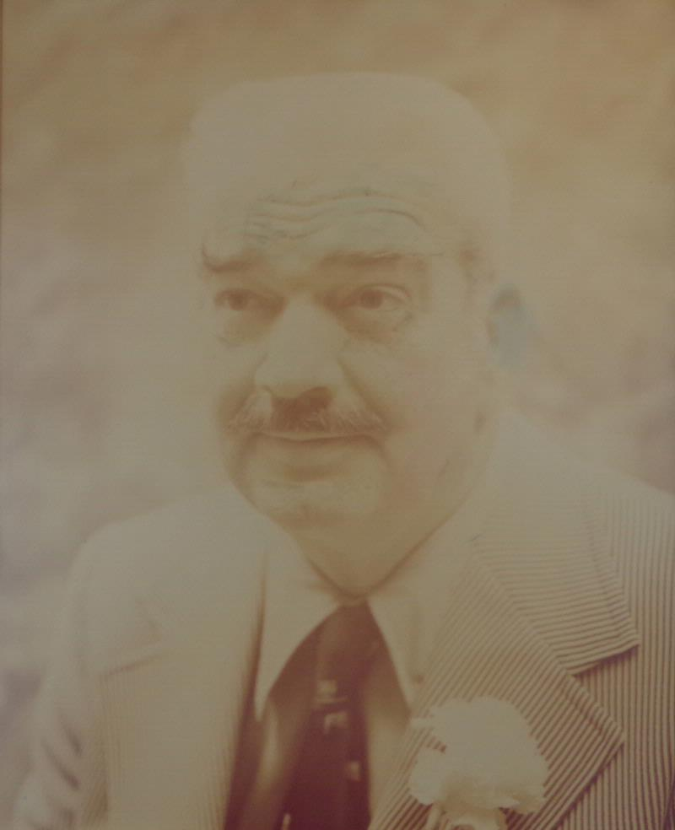

Student Demographics
984 Students

Ethnic Distribution
Hispanic: 88.6%
African American: 8.9%
White: 1.1%
American Indian: .1%
Asian: 1.2%

Other Population Information
Economically Disadvantaged: 89.5%
English Language Learners: 16.9%
At-Risk: 49.4%
Mobility Rate: 17.8%

Students’ Success
(STAAR Percent at Phase-in 1 Level II or Above)
Subject | State | District | Campus
Reading | 77 | 66 | 70
Writing | 72 | 61 | 60
Mathematics | 81 | 73 | 100
Science | 78 | 69 | 61
Social Studies | 78 | 69 | 52

For more information about this campus, please see the Texas Academic Performance Report at Pagehttps://rptsvr1.tea.texas.gov/perfreport/tapr/2015/index.html.

For information on open positions or to submit your resume, please visit our Web site at: www.lucernepublishing.com
Campus Departments, Clubs, and Activities

Departments:
Science
Mathematics
Social Studies
Language Arts
Foreign Language
Career Exploration
Physical Education/Athletics
Fine Arts

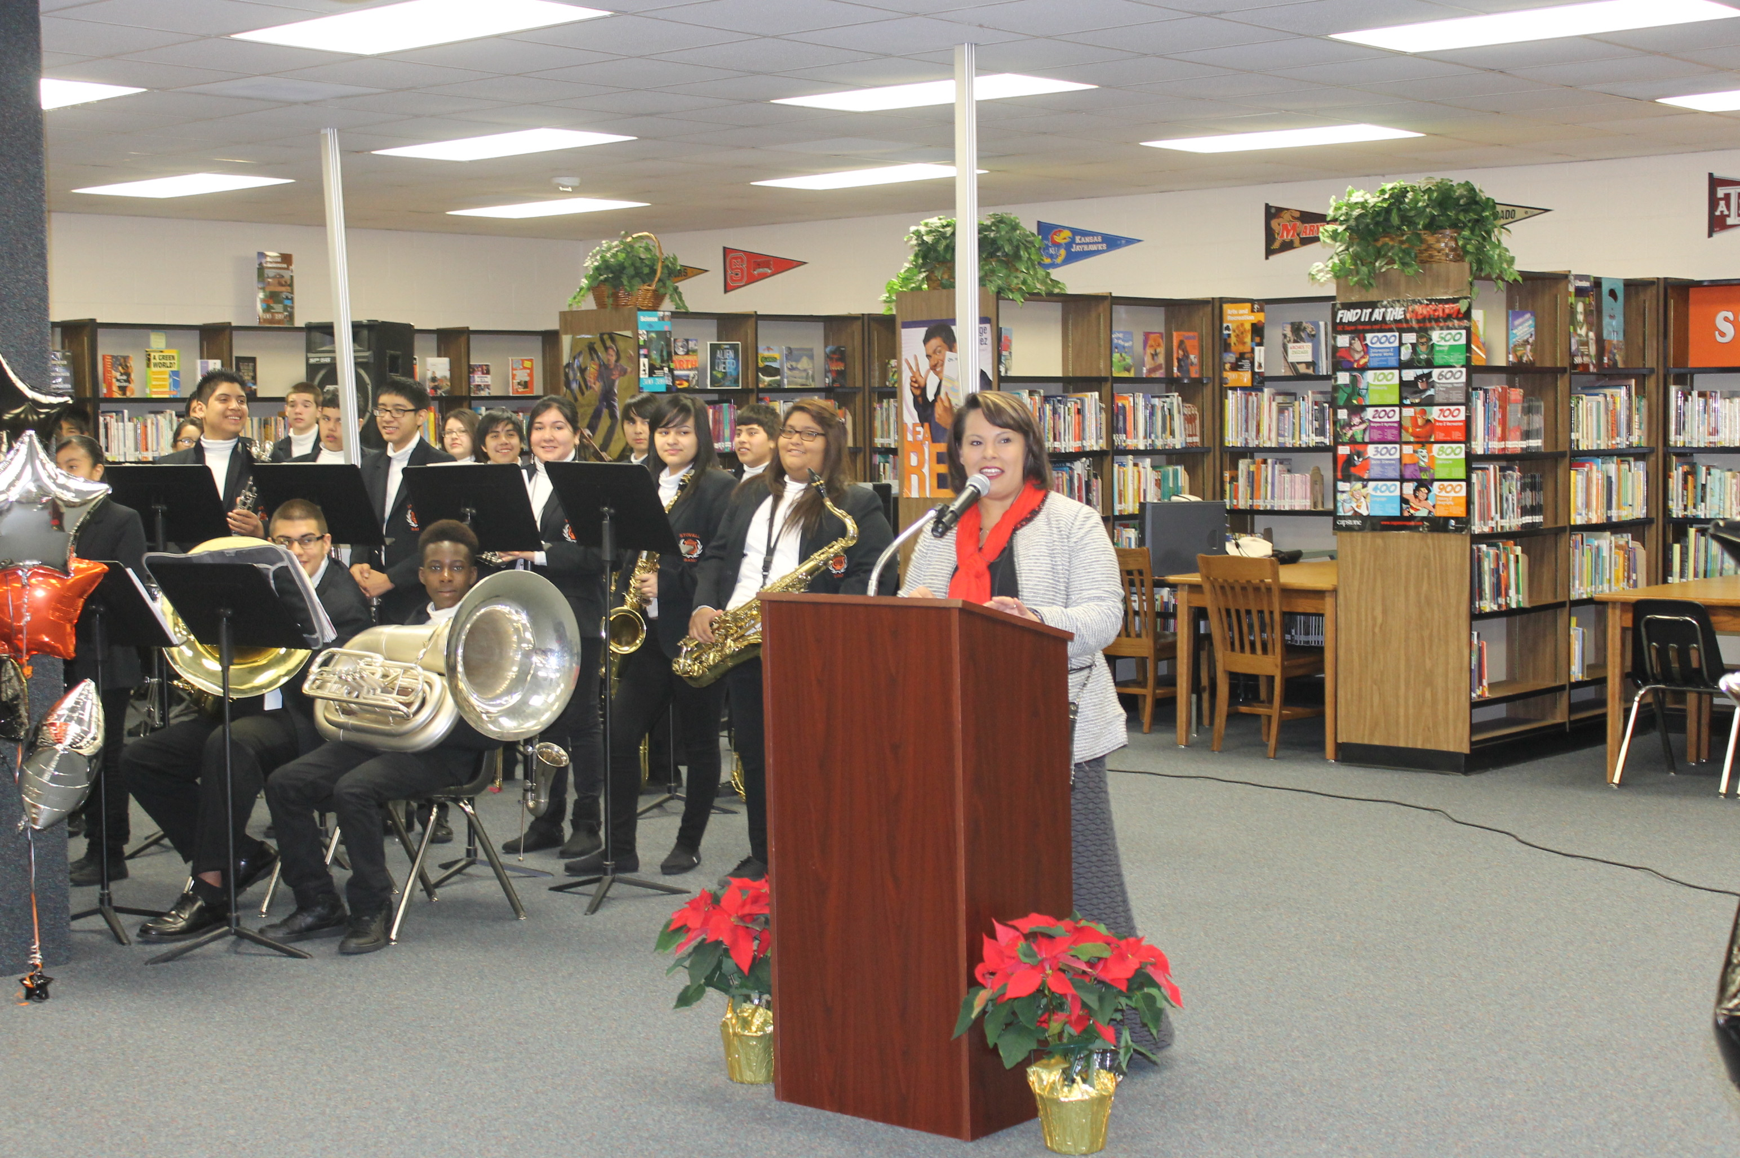

Clubs and Activities:
Chess
Academic Pentathlon
Student Ambassadors
Spanish
Science Fair
History Fair
Step Team
National Jr. Honor Society

Math Distinction
2015

